**C:\Documents and Settings\winxpuser\Local Settings\Temporary Internet Files\Content.IE5\G1C1FG4K\MC900092643[1].wmf**

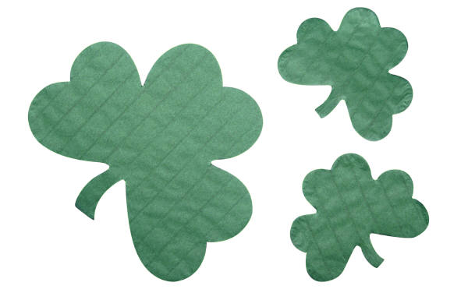





**St. Patrick’s Day is observed on March 17** because that is the feast day of St. Patrick, the patron saint of Ireland. It is believed that he died on March 17 in the year 461 AD. It is also a worldwide celebration of Irish culture and history. St. Patrick’s Day is a national holiday in Ireland and a provincial holiday in the Canadian province of Newfoundland and Labrador.

**Many cities have a St. Patrick’s Day parade.** Dublin, the capital of Ireland, has a huge St. Patrick’s Day festival from March 15-19 that features a parade, family carnivals, treasure hunt, dance, theatre and more. In North America, parades are often held on the Sunday before March 17. Some paint the yellow street lines green for the day! In Chicago, the Chicago River is dyed green with a special dye that only lasts a few hours. There has been a St. Patrick’s Day parade in Boston, Massachusetts since 1737. Montreal is home to Canada’s longest running St. Patrick’s Day parade, which began in 1824.



**St. Patrick was born in 385 AD** somewhere along the west coast of Britain. At age 16, he was captured and sold into slavery to a sheep farmer. He escaped when he was 22 and spent the next 12 years in a monastery. In his 30s he returned to Ireland as a Christian missionary. According to legend St. Patrick drove the snakes out of Ireland. He died at Saul in 461 AD and is buried at Downpatrick.

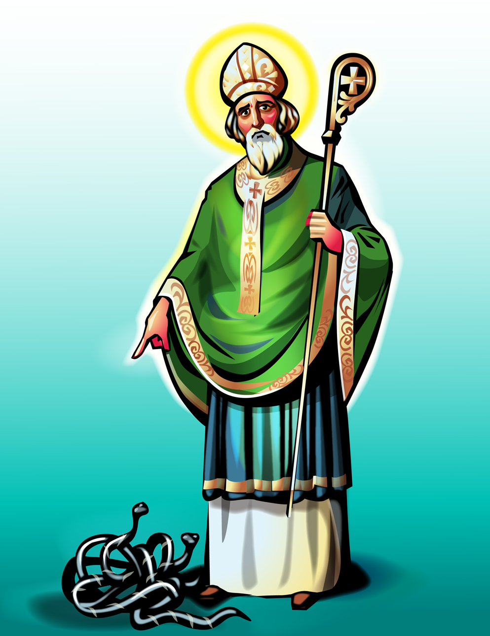



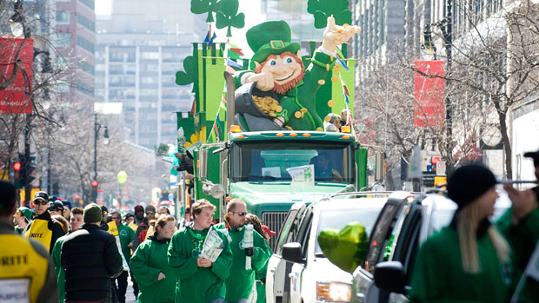

C:\Documents and Settings\winxpuser\Local Settings\Temporary Internet Files\Content.IE5\G1C1FG4K\MC900245633[1].wmf

**In Ireland on St. Patrick’s Day**, people traditionally wear a small bunch of shamrocks on their jackets or caps. Children wear orange, white and green badges, and women and girls wear green ribbons in their hair.





**The harp and the shamrock are symbols of Ireland.** The colour green is also commonly associated with Ireland, which is also known as “the Emerald Isle.”

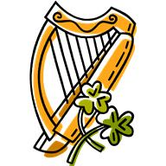

A **leprechaun** (lep' rah kahn) is a mythical Irish elf or fairy. A leprechaun is a small man less than 24 inches (610 mm) in height with thick, wiry red hair. All leprechauns wear shiny black leather shoes with silver buckles, as they are excellent cobblers or shoemakers. According to legend each leprechaun guards a pot of gold which is kept at the end of a rainbow.



**Some American towns have “Irish” names.** You could visit: Mount Gay-Shamrock, West Virginia; Shamrock Lakes, Indiana; Shamrock, Oklahoma; Shamrock, Texas; Dublin, California and Dublin, Ohio.



**The Irish flag is green, white and orange.** The green symbolizes the people of the south, and orange, the people of the north. White represents the peace that brings them together as a nation.



**36 million Americans have Irish ancestry**, according to the 2008 US Census. That’s almost nine times the population of Ireland, which has 4.1 million people.

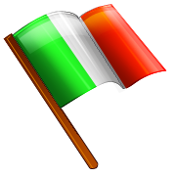

|  |  |  |  |  |
| --- | --- | --- | --- | --- |
|  | | **C:\Documents and Settings\winxpuser\Local Settings\Temporary Internet Files\Content.IE5\YEEJP82P\MC900092645[1].wmf** |  | |
|  | | Based on the reading text are the following statements true (T) or false (F)? Correct any false statements.   1. St. Patrick’s Day is celebrated only in Ireland. 2. St. Patrick was Irish. 3. St. Patrick got rid of the snakes in Ireland. 4. Dublin, Ireland has a St. Patrick’s Day festival from March 15-19. 5. A leprechaun is a male fairy. 6. The number of Americans of Irish ancestry is equal to the population of Ireland. 7. According to legend leprechauns keep their pot of gold at the end of a rainbow. 8. Another name for Ireland is the Sapphire Isle. 9. The green in the Irish flag represents the people of the north, and orange the people of the south. 10. There are American cities named Dublin in California and Ohio.   **Answer Key**   1. F (celebrated in many cities around the world) 2. F (English) 3. T 4. T 5. T 6. F (9 times the population of Ireland) 7. T 8. F (The Emerald Isle) 9. F (green represents the people in the south; orange the people in the north) 10. T | | |  | |