Charlotte Brotë
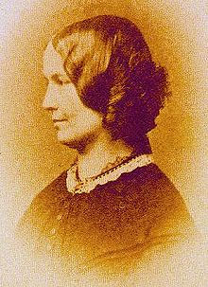
Charlotte Brontë, 1816 to 1855, was the eldest of the three famous Brontë sisters and the author of the well-loved English classic, Jane Eyre.
Charlotte was born in Yorkshire as the third of six children of a clergyman. Her mother died when she was only five and she was raised mainly by her aunt, Elizabeth Bramwell.
Charlotte and her two older sisters were sent at a very young age to a harsh boarding school, the conditions of which probably contributed to the deaths of the two older siblings of tuberculosis and left Charlotte's health poor for the rest of her life. She used the conditions of the school as the basis for the awful Lowood School in Jane Eyre.
Allowed to have the rest of her education at home with her two younger sisters, Anne and Emily, and her brother Bramwell, the children created and wrote about vivid imaginery worlds in stories, articles and poems.
As an adult Charlotte spent time as a teacher and as a governess, both in England and in Brussels.
Charlotte wrote under the pseudonym "Currer Bell". Her first manuscript, The Professor, was not published until after her death, but her second, Jane Eyre, was received enthusiastically by a London publisher and an immediate success both in terms of reviews and profit!
Tragedy struck the Brontë family. Bramwell, Emily and Anne Brontë all died within 8 months of each other, and Charlotte wrote her second novel, Shirley, published in 1849, as a way of dealing with her grief. Perhaps as a result of her loneliness she also revealed her identity and became friends with other well-known novelists of the time such as Elizabeth Gaskell.
Charlotte's third novel, Villette, was published in 1853, and in 1854 she married, soon becoming pregnant. Sadly her pregnancy was difficult and she died in 1855, aged 38.

