William Shakespeare
23rd April 2016 will be the 400th anniversary of Shakespeare's death.

Who Was William Shakespeare?
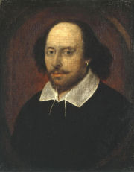
William Shakespeare was an English playwright and poet, widely regarded as one of the greatest ever English writers. Some of Shakespeare’s better known plays include ‘Romeo & Juliet’, ‘Hamlet’ and ‘Much Ado About Nothing’.
Shakespeare was born and lived in Stratford-upon-Avon in 1564 before moving to London to become an actor at age 21. Shakespeare wrote different genres of plays throughout his career, starting out mainly with comedies and histories before moving on to tragedies as he grew older.
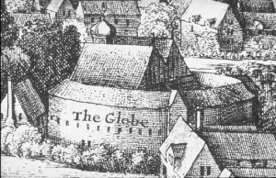
In 1599, along with some fellow actors, Shakespeare built a theatre on the South Bank of the River Thames which he named ‘The Globe’. It was here that many of his plays were performed. Today, visitors to London can still watch Shakespeare plays at the restored Globe Theatre.
William Shakespeare was a very well-known character in Tudor England. It is thought that Elizabeth I was a fan of his plays.
Fun fact: William Shakespeare was the only member of his family that could read or write!
"A fool thinks himself to be wise, but a wise man knows himself to be a fool."
William Shakespeare.

