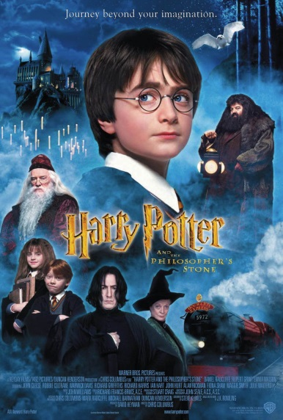
HARRY POTTER AND THE PHILOSOPHER´S STONE
- Which birthday does Harry celebrate in this film / book?
His 11th
- Where does Harry sleep at the Dursleys´ before going to Hogwarts?
In the cupboard under the stairs
- Who killed Mr. and Mrs. Potter?
Voldemort
- Which bank vault in Gringotts contained the Philopsher's stone?
Vault 713
- In which London station do you stand between platform 9 and 10 to catch the train to Hogwarts?
In King´s Cross
- Who helped Harry find the right platform for the train?
Mrs Weasley
- What are the names of the Weasley twins?
Fred and George
- What house did the Sorting Hat want to assign him to first?
Slytherin
- What´s the name of the groundkeeper at Hogwarts?
Hagrid
- What is the spell that makes objects fly? Wingardium Leviosa And the one that opens doors? Alohomora
- Who is Nearly Headless Nick?
Gryffindor Ghost
- What are Wood and Harry´s positions in the Quidditch team?
Wood is the keeper and Harry the seeker
- Which teams are involved in Harry´s first match?
Slytherin and Gryffindor
- What model is Harry´s broom?
A Nimbus 2000
- Who gave Harry that broom?
Professor Minerva Mcgonagall
- What is the name of the mirror where Harry sees his parents?
Erised
- What creature interrupted the Halloween feast?
A troll
- How does Hagrid call the three-headed dog? Fluffy
And his own dog? Fangs
- What do Harry, Ron and Hermione find in the forbidden area
on the 3rd floor?
A three-headed dog
- What game did Harry, Hermione, and Ron have to play to get
across the room?
Chess / The Wizard Chess
- Who was trying to steal the Sorcerer’s Stone?
Professor Quirrell
- Who is the teacher who Harry thinks is working with
Voldemort?
Severus Snape
- What dropped in Harry’s pocket as he looked in the magic
mirror?
The Philosopher´s Stone
- Which character do you like most and which do you least?
Free answer

