JESSE OWENS
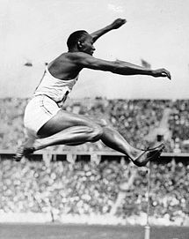
James Cleveland "Jesse" Owens (1913 – 1980) was an American track and field athlete and four-time Olympic gold medallist in the 1936 games.
At the 1936 Summer Olympics in Berlin, Germany, Owens won international fame with four gold medals: 100 meters, 200 meters, long jump, and 4 × 100 meter relay.
Owens's success at the games represented a counter to Adolf Hitler, who was using the games to show the world a resurgent Nazi Germany. He and other government officials had high hopes that German athletes would dominate the games with victories. Meanwhile, Nazi propaganda promoted concepts of "Aryan racial superiority" and depicted others, including those of African descent, as inferior. Owens countered this by winning four gold medals.
Hitler was highly annoyed by the series of triumphs by the marvellous coloured American runner, Jesse Owens. People whose antecedents came from the jungle were primitive, Hitler said with a shrug; their physiques were stronger than those of civilized whites and hence should be excluded from future games.
However, Owens felt the newspapers of the day reported 'unfairly' on Hitler's attitude towards him. Owens showed some people a photograph of Hitler shaking hands with him and told them: "That was one of my most beautiful moments." The picture was taken behind the honour stand and so not captured by the world's press. The predominating opinion in post-war Germany was that Hitler had ignored Owens. The consensus was that Hitler had to continue to be painted in a bad light in relation to Owens.
In Germany, Owens had been allowed to travel with and stay in the same hotels as whites, at a time when African Americans in many parts of the United States had to stay in segregated hotels. During a Manhattan ticker-tape parade along Broadway's Canyon of Heroes in his honour, someone handed Owens a paper bag. Owens paid it little mind until the parade concluded. When he opened it up, he found the bag contained $10,000 in cash.
After the parade, Owens was not permitted to enter through the main doors of the Waldorf Astoria New York and instead forced to travel up to the event in a freight elevator to reach the reception honouring him. President Franklin D. Roosevelt (FDR) never invited Jesse Owens to the White House following his triumphs at the Olympics games.
“Some people say Hitler snubbed me. But I tell you, Hitler did not snub me. The President did not send me a message of congratulations because, people said, he was too busy.” "Hitler didn't snub me – it was our president who snubbed me. The president didn't even send me a telegram.”

Carl Ludwig "Lu(t)z" Long
(1913 – 1943) was a German Olympic long-jumper, notable for winning Silver in the event at the 1936 Summer Olympics in Berlin and for giving advice to his competitor, Jesse Owens, who went on to win the gold medal for the long jump as a result of Long's advice.
Luz Long won the German long jump championship six times in 1933, 1934, 1936, 1937, 1938, and 1939.
Long was killed in action serving in the German Army during World War II.
For his actions in the spirit of sportsmanship, he was posthumously awarded the Pierre de Coubertin medal.
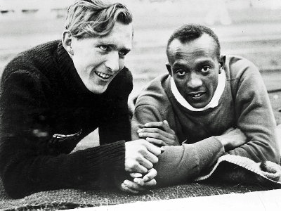

World War II
Long served in the Wehrmacht during World War II. During the Allied invasion of Sicily, Long was killed in action in 1943. He was survived by two sons, Kai-Heinrich and Wolfgang. Kai was born in 1941 and Wolfgang was born on 30 May 1943, but died on 6 March 1944.
Long and Owens corresponded after 1936. In his last letter, Long wrote to Owens and asked him to contact his son after the war and tell him about his father and "what times were like when we were not separated by war. I am saying—tell him how things can be between men on this earth". After the war, Owens travelled to Germany to meet Kai Long. Owens later served as Kai Long's best man at his wedding.

