FICHA 4 – MATERIAL PENDIENTES DE INGLÉS

VOCABULARY

1 Find the words for disasters in the puzzles. Then use them to complete the sentences below.
a. b. c.
r
a
v
l
f
e
s
i
r
c
b
k
t
p
e
r
m
t
a
a
k
j
h
t
q
u
n
e
e
s
p
k
t
g
u
o
r
f
w
m
h
d
d. e.
a
i
o
o
p
r
d
l
z
f
t
m
e
s
o
c
l
u
o
g
p
n
v
q
t
h
d
r
1. We didn’t go sailing because there was a …………………… .
2. Many houses were under water because of the …………………… .
3. The animals are running. There’s a big …………………… in the forest.
4. There was a terrible …………………… because it didn’t rain for five years.
5. Did you feel the …………………… this morning?

2 Complete the dialogues with the words below.
hurricane • volcanic eruption • tsunami • tornado • avalanche
1. A: There was a …………………… in the Indian Ocean.
B: I know. It started with an earthquake under the sea.
2. A: Did you read about the …………………… in the mountains yesterday?
B: Yes. People are still looking for skiers in the snow.
3. A: Can you see that? A …………………… is coming.
B: Yes, the clouds are black and the wind is turning round and round.
4. A: There was a …………………… in Texas last week.
B: I know. I read that many people lost their homes in that terrible storm.
5. A: Do you know what happened in Pompeii?
B: Yes. There was a …………………… of Mount Vesuvius in 79 AD. It destroyed the city.

GRAMMAR

3 What were the people doing at 10.00 on Saturday morning? Complete the sentences with the verbs in brackets.
Use the Past Continuous affirmative or negative.
10.00 Saturday morning

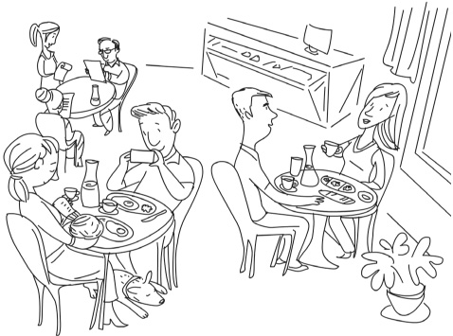
Dena
Betty
Ann
Dave
Rob
Katy
George
1. Katy and Rob ……………………………… breakfast. They ………………………………dinner. (have)
2. Dave ………………………………a picture of the dog. He ………………………………a picture of Ann
and the baby. (take)
3. Ann ………………………………her baby. She ………………………………her dog. (feed)
4. George and Betty ………………………………the menu. They ………………………………a book. (read)
5. Dena ………………………………to her friend. She ………………………………to George and Betty. (talk)

4 Write questions with the words below and the Past Continuous. Then match the questions to the answers.
1. it / snow / in the mountains / this morning

2. what / you / watch / at 8 o’clock

3. where / George and Ben / go / at 5.00

4. Lara / prepare / lunch / at 12.00

5. you / talk / to Tommy / at 4 o’clock

...... a. No, she wasn’t.
...... b. Yes, I was.
...... c. the news
...... d. Yes, it was.
...... e. to the shopping centre

