FICHA 3 – MATERIAL PENDIENTES 2 ESO
VOCABULARY

1 Use all the letters below to complete the weather words. Then match the words to the pictures.
c • d • f • a • m • g • i • l • n • t • o • s • r • w • y
1. c ...... o u ...... y 4. ...... c y 7. w ...... ...... m
2. ...... ...... owy 5. ...... ...... o l 8. s ...... o r ...... y
3. ...... i n d ...... 6. ...... o ...... g y
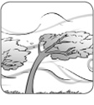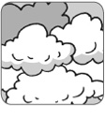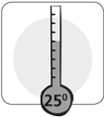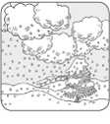
a

b

c

d

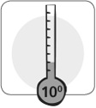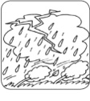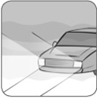
e

f

g

h

2 The words in bold are in the wrong sentences. Write them next to the correct sentences.
1. It’s sunny outside, so I’m taking an umbrella. ……………………
2. Put on your sweater. It’s hot outside. ……………………
3. Drive slowly. The roads are dry. ……………………
4. Take off your jacket. It’s cold in here. ……………………
5. We water the plants when the garden is wet. ……………………
6. It’s rainy outside. You should put on some sun cream. ……………………

GRAMMAR

3 Complete the sentences with the verbs in brackets to describe what was happening
on Sunday at 12.00. Use the Past Continuous affirmative.
1. The boys ……………………………… (play) computer games.
2. Grandfather ……………………………… (watch) TV.
3. The baby ……………………………… (cry).
4. Mum and Dad ……………………………… (clean) the kitchen.
5. The cat ……………………………… (sleep) on the sofa.
6. Grandmother ……………………………… (write) a letter.

4 Look at the picture. Correct the sentences in Exercise 3. Use the Past Continuous
affirmative and negative and the words below.
watch TV • eat its food • read a book • drink milk • sleep • make dinner
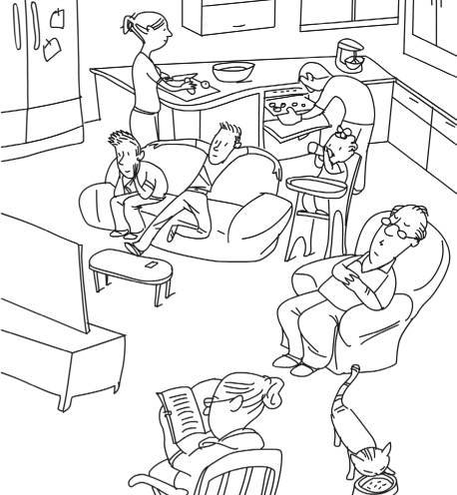
1. The boys .
weren’t playing computer games. They were watching TV

2. Grandfather .
3. The baby .
4. Mum and Dad .
5. The cat .
6. Grandmother

5 Write questions with the words below. Use the Past Continuous.
Then answer the questions. Make them true for you.
1. what / you / do / at 7.00 this morning

2. it / rain / at midnight

3. you / watch TV / at 10.00 last night

