FICHA 2 – MATERIAL PENDIENTES 2 ESO
VOCABULARY

1 Choose the correct answer.
1. Sara is crying because she returned / created / broke her leg.
2. Please post / survive / hear this letter for me.
3. Did you grow / drop / stay my glass?
4. The box is very big. Please help me pay / keep / lift it.
5. When did your dog die / post / break?
6. Do you hurt / keep / stay your paintbrushes in this box?

2 Match A to B.
A
1. There was a terrible train accident.
2. Ann is very good at art.
3. Jim has got an expensive car.
4. Sammy fell out of the tree.
5. Mum went shopping at 4 o’clock.
6. Grandfather listens to loud music.
7. Where do you go in the summer?
8. We bought some new plants.
B
...... a. She creates beautiful paintings.
...... b. He doesn’t hear very well.
...... c. Not many people survived.
...... d. They are growing very fast.
...... e. He hurt his head.
...... f. We usually stay on our uncle’s farm.
...... g. He paid a lot of money for it.
...... h. She returned after an hour.

GRAMMAR

3 Complete the sentences with the verbs below. Use the Past Simple negative. There are more verbs than you need.
walk • smile • watch • grow • hold • stay • hear • kiss • buy
1. I’m hungry because I ……………………………… lunch at the cafeteria.
2. Last summer, we ……………………………… any vegetables in our garden.
3. Ann and Max came to visit but they ……………………………… long.
4. The baby ……………………………… because she was ill.
5. Harry ……………………………… to work because it was raining.
6. My grandfather was asleep. He ……………………………… us come in.

4 What DIDN’T Ann do yesterday? Look at the pictures and write sentences in the Past Simple negative.
Choose from the phrases below.
do the dishes • sweep the floor • feed the dog • water the plant • make her bed
take out the rubbish • listen to music • have breakfast
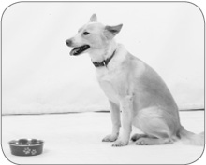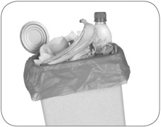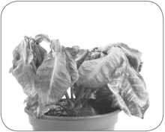
1
2
3
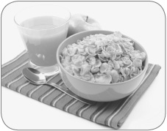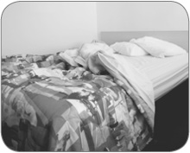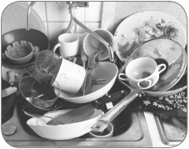
4
5
6
1.
2.
3.
4.
5.
6.

5 Complete the dialogue with the verbs in brackets. Use the Past Simple affirmative, negative and interrogative.
A: When ^{1.} ……………………you …………………… (return) from your holiday in Paris?
B: We ^{2.} …………………… (get) back yesterday.
A: ^{3.} ……………………you …………………… (enjoy) yourselves?
B: Oh yes, it was great. We ^{4.} …………………… (visit) the Louvre and I ^{5.} …………………… (see)
the famous Mona Lisa.
A: ^{6.} ……………………you …………………… (buy) any new clothes?
B: No, we ^{7.} …………………… (have) time.

