MATERIAL – ALUMNOS CON INGLÉS PENDIENTE DE 2 ESO
VOCABULARY

1 Write the words under the correct picture.
brain • tongue • face • beak • claws • paws • shoulder • elbow • feathers • heart • knee • neck

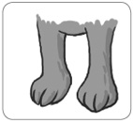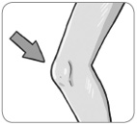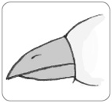
1
2
3

…………………… …………………… ……………………

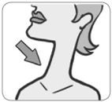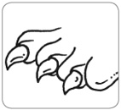
4
5
6

…………………… …………………… ……………………

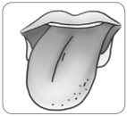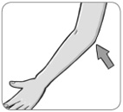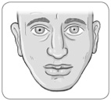
7
8
9

…………………… …………………… ……………………

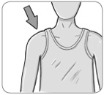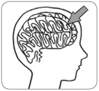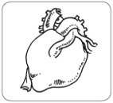
10
11
12

…………………… …………………… ……………………

2 Circle the word that doesn’t belong. Then match it to the correct definition below.
1. beaks • paws • feathers • claws
2. face • forehead • brain • back
3. shoulder • blood • stomach • heart
4. knee • elbow • neck • eyebrow
...... a. It isn’t inside your body.
...... b. It isn’t part of your head.
...... c. Birds haven’t got these.
...... d. Your body has got only one.

grammar

3 Complete the sentences with one of the verbs in brackets. Use the Past Simple negative.
1. I ……………………………… (ride / drive / find) my bike to school this morning.
2. Dave ……………………………… (help / study / write) a letter to his friend yesterday.
3. Myra ……………………………… (laugh / watch / visit) TV last night.
4. It ……………………………… (rain / feel / become) yesterday. It was a beautiful day.
5. Elsa ……………………………… (put / wear / cry) her new dress yesterday.
6. Lila ……………………………… (enjoy / know / bake) a cake for the party.

4 Complete the sentences with the verbs below. Use the Past Simple, affirmative or negative.
feed • cook • tidy • know • get
1. We didn’t order pizza because Sara ……………………………… dinner.
2. I ……………………………… my room yesterday because I was tired.
3. Our teacher was ill yesterday, so we ……………………………… any homework.
4. My fish look hungry. I ……………………………… them yesterday.
5. I’m happy. We had a test and I ……………………………… all the answers.

5 Write questions with the words below. Use the Past Simple. Then match them to the answers.
1. Abel Tasman / discover / New Zealand

2. when / Columbus / sail across / the Atlantic Ocean

3. where / Count Dracula / live

4. how / Marco Polo / travel / to China

5. why / thousands of people / go / to California / in 1849

...... a. by ship, camel and horse
...... b. to find gold
...... c. in 1492
...... d. Yes, he did.
...... e. in a castle in Romania

