3 ESO –FICHA 1 GRAMMAR&VOCABULARY
Extra Practice 1

Vocabulary

1 Where can you find these people? Look at the pictures and complete the words.

1
2
p … … … … … s … … … … … … s … … … … … … … p … … …
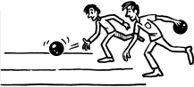
3

4
n … … … … c … … … b … … … … … … a … … … …
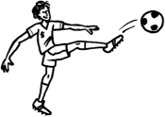
5
6
r … … … … … … t … … … … f … … … … … … … p … … … …
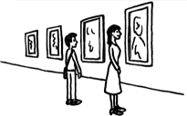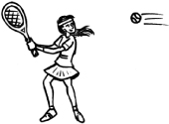
7
8
a … … g … … … … … … t … … … … … c … … … …

2 Complete the sentences with the words below.
market  office block  railway station  hotel  car park  university  playground  airport  newsagent
1. John is studying art at …………………… .
2. I buy all my vegetables at the …………………… .
3. Many people work in that big …………………… .
4. Do you buy your magazines at the …………………… near your house?
5. About 20 aeroplanes arrive at this …………………… every hour.
6. There’s a huge …………………… for children in the park.
7. Let’s park our car in the …………………… near the cinema.
8. The train is arriving at the central …………………… at 7.30 am.
9. Uncle Dan is staying at the new …………………… for three nights.

Grammar

3 Choose the correct time expression.
1. Where is Paul going every day / sometimes / now?
2. Does the train stop here tomorrow / at the moment / every morning?
3. Our friends always / right now / today go to the cinema near the gym.
4. The students aren’t studying this week / every day / often.
5. I don’t now / usually / never have a meal before I go to the sports centre.

4 Complete the sentences with the verbs below. Use the Present Simple or Present Continuous.
not know  drive  visit  need  study
1. Bob …………………… to town now.
2. We …………………… science twice a week.
3. I …………………… to buy a train ticket.
4. Sally …………………… her aunt tomorrow.
5. Those men …………………… where the car park is.

5 Write the questions with the words below. Use the Present Simple or Present Continuous.
1. Where / Mary and Tom / work

2. What / you / look at / right now

3. When / your parents / usually / go / to the cinema

4. What / book / Adam / read / now

5. How often / Alice / travel / to the US

6 Match the questions in Exercise 5 to the answers below.
...... a. About once a month.
...... b. Travels with Marley.
...... c. In that office block.
...... d. An e-mail from Rose.
...... e. On Friday nights.
EXTRA PRACTICE 2

Vocabulary

1 Complete the words according to the pictures.
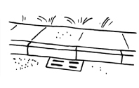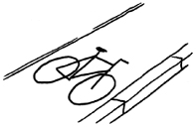
1
2
p … … e … … n … b … c … c … … l … … e
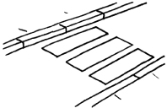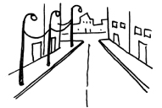
3
4
… e b … … c … … s … i n … s … … … e …

2 Complete the puzzle. Use the clues.
 |  |  |  |  | ¹
 |  |  |  |  |  |  |  |  |  |  | ²
 |  |  | ³ |  |  |  |  |  | ⁴
 |  | ⁵
 |  | ⁶
⁷

Across 
1. 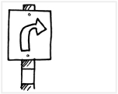 3. 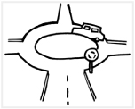 6.  7. 
Down 
1. 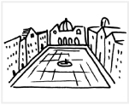 2.  4. 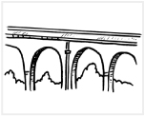 5. 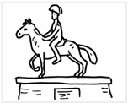

Grammar

3 Choose the correct answer.
1. There isn’t many / much fruit at home. Let’s go to the market.
2. I want some / any ice cream!
3. Is that red notebook on a / the desk?
4. I can see much / a lot of people on the beach.
5. Ron rides an / a orange motorbike.
6. There aren’t some / any running tracks in our town.

4 Complete the sentences with the words below.
some  any  a  an  how much  a lot of  how many
1. We’ve got …………………… time to go shopping for shoes – four hours!
2. Is there …………………… fountain in the square?
3. I want to sit under …………………… umbrella on the beach.
4. …………………… money have you got?
5. Are there …………………… cars in the car park?
6. Tomorrow, Pam is going to the nightclub with …………………… friends.
7. …………………… rooms are there in the hotel?

5 Choose the correct answer.
Bob: Hi, Emily. What ^{1.} are you doing / do you do / does you do now?
Emily: I’m looking at ^{2.} any / some / an photos of our class. I’ve got
^{3.} a lot of / much / a photos of you.
Bob: Really? Can you send me ^{4.} many / some / much photos, please?
I never take ^{5.} some / the / any photos.
Emily: Sure! You ^{6.} doesn’t often smile / don’t often smile /
aren’t often smiling in photos, but look at this one. You
^{7.} is laughing / laugh / are laughing!
Bob: Yes, you’re right.

