The Simpson Family

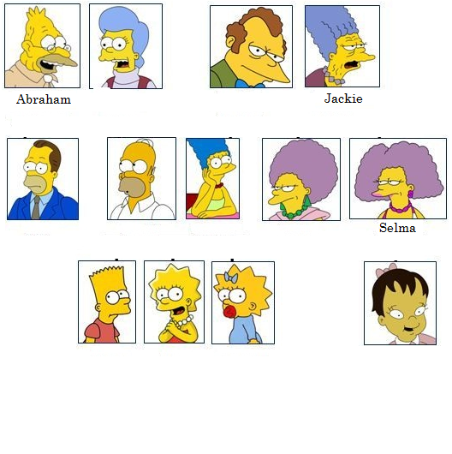
1. a) Read the text and complete the family tree.
This family is very big. Abraham is the father of Homer, and Mona is mother of Homer. Herb is the brother of Homer. Marge is the wife of Homer. Her father is Clancy and her mother is Jackie. Marge has 2 sisters, Patty and Selma. Selma has a daughter called Ling. Homer and Marge have 3 children. The son is Bart and the two daughters are Lisa and Maggie.

1. b) Read the text again. True (T) or False (F).
9
20
- The Simpsons family is small.
- Marge has one brother and one sister.
- Ling is the daughter of Selma.
- Homer and Marge have 3 children.
- Homer and Marge have 2 sons and 1 daughter. | - Jackie is the of Lisa.  - Ling is the of Bart and Lisa.  - Maggie is a  - Herb is the of Lisa.  - Homer is the of Marge.  - Marge is the of Patty and Selma.
2. Complete the sentences.
- Maggie is the of Marge and Homer.
- Bart is the of Lisa.
- Marge is the of Homer.
- Abraham is the of Bart.
5) Patty is the of Maggie.

3. Write about you and your family.

