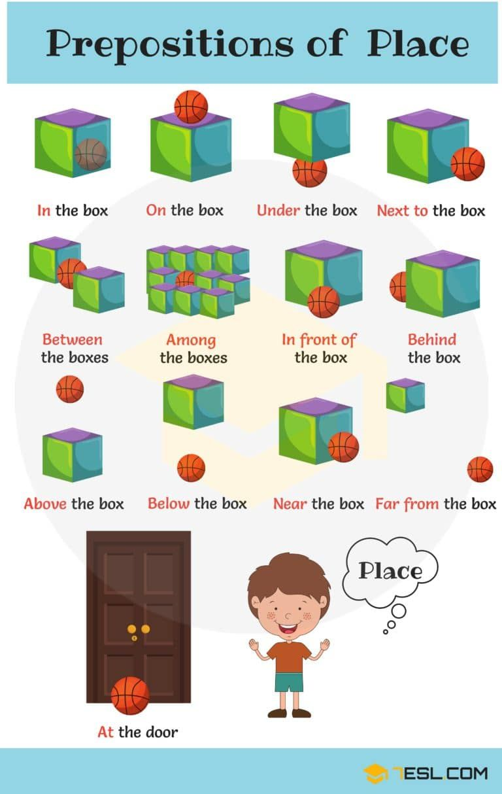
Here you are a prepositions song to help you.
https://www.youtube.com/watch?v=h19wLvYWmQE

