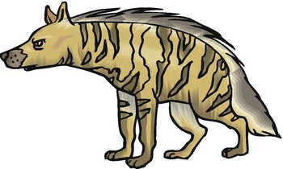 |  |  |  |  | 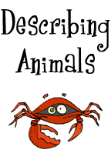  Across  3. Lobsters and crabs have these.  5. Something on deer's head.  8. An elephant's nose.  9. A cat’s feet.  11. These protect the skin of reptiles and fish.  12. Something an elephant and a walrus have in common.  14. Fish use these to breathe.  16. Birds have these all over their body.  18. Something on a bull's head.  19. Mammals use these to breathe.
Down  1. This swings at the back end of many animals.  2. A horses feet.  4. Something a zebra and a tiger have in common.  6. What a squid and a jellyfish have in common  7. A bird's mouth. |  | 10. Many animals use these to fly.  13. Something a cheetah and giraffe have in common.  15. Something a turtle and a snail have in common.  16. Animal hair.  17. Snake poison. |  | 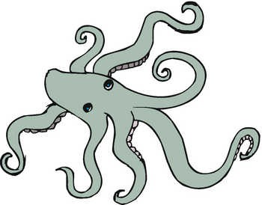
© 2005 www.bogglesworldesl.com

