EXAME MAIO ESA ( MÓDULO III). CONVOCATORIA EXTRAORDINARIA

NAME__________________________________________________________________________

A)Choose or answer the right question. (5 marks)

- What is Thanksgiving common food?

- The Pilgrims Fathers set sail from ____________________ to America

- Scotland b) Wales c) England
- The pilgrims sailed to America on a ship called________________

- Titanis b) Mayfair c) Mayflower

- Thanksgiving is also celebrated in Canada on the first Thursday of November / fourth Tuesday of December /second Monday of October

- The First Thanksgiving Day was celebrated in ________________________

- Washington b) Plymouth c) New York

- Who helped and taught the Pilgrims to grow food?

- Why did the Pilgrims leave Europe?

- To look for gold b) To seek a land of liberty c) To capture new territories

- What is the Black Friday? How was it originated?

- Sweet food made of sugar given in Halloween._______________

- A brush on the end of a long handle that witches use to fly.________________

- When do people celebrate Halloween?

- What is a Jack-O’latern? Tell its story and a similar one in Galicia.

- What bird is cooked for Christmas dinner?

- What do you do under mistletoe?

- Who helps Santa to make toys?

- When is the Boxing Day?

- Give another name for Santa.Which Ocen is Christmas Island in?

- What is the traditional Sunday lunch?

- How many countries are there in the U.K.?

- Which country in Britain has road signs written in two languages?

- Wales b) England c) Scotland

- Where are the Crown Jewels kept?

- Buckingham Palce b) The Tower of London c) Westminster Abbey

d) The Big Ben.

22. Who was born in Stradford-Upon-Avon?

- Charles Dicken b) Willian Shakespeare d) Winston Churchill

23. You can drive in Britain when you are 16/ 17/ 18/ 21.

24. What is the name of the highest mountain in Britain?

25 Who is the patron saint of England?

- St David b) St George c) St Patrick d) St Andrew
26. Match these words to their meanings.
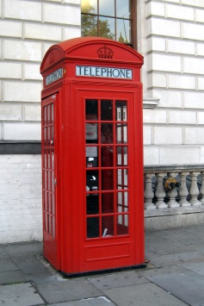
- a quid a) a cup of tea
- a cuppa b) a short sleep
- a telly c) an umbrella
- a loo d) £1
- a brolly e) a television
- a kip f) a toilet

B) GEOGRAPHY (2mark)
Write the names of the countries in the box, and the capital cities on the line.
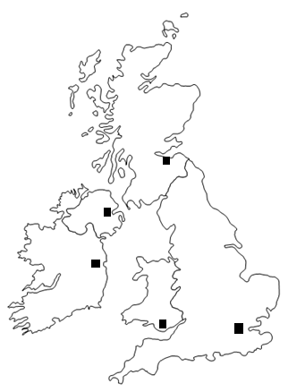

Complete the grid:
 | 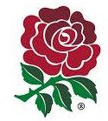 |  | 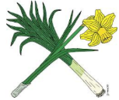 | 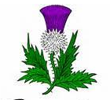
NAME OF THE SYMBOL
COUNTRY

- Complete :

GREAT-BRITAIN = ________________+ _______________+ ______________

The UNITED-KINGDOM = _____________________+ _____________________

C) GRAMMAR ( 1 MARK)

1Write and say the following email addresses. Escriba e diga os enderezos de correo.(0.25)

AIMGLEZ@EDU.XUNTA.ES
BART_SIMP@USA.ES

2 Fill in with BE or HAVE GOT and their negatives. (0.25)

Hello! My name (1)....................... Susan. I (2)............................. a student.
I (3)......................... eleven years old and I like school very much. At our school the children (4).......................... from 11 to 18 years old. I (5).................... in grade 7 in class 7D. My teachers (6)..................... friendly and I like them, too. My class teacher (7)................. Mrs Wise.
We (8).................................. 4 or 5 lessons a day. Our lessons (9)............................... 45 minutes long. My favourite school subject (10)............................ English. We (11).................... English each day. I don´t like Maths. My favourite schoolday (12)............................ Friday, because it (13)................... easy. I don’t like Tuesdays and Thursdays, because they (14)................ difficult days.
Between the lessons we (15)................................. breaks. They (16).................... 15 minutes long. During the breaks I (17)............ in the playground with my friends.
I (18)……………….. a lot of friends at school. Ann (19)............................ my best friend and my desk mate.
My school (20)....................... very big . It (21)............................ a lot of classrooms, a library, a canteen, a gym and a big playground.
In the afternoon I (22).......................... lessons. We (23) .................. a lot of homework, so we (24)......................... in our classroom and write or learn it.
On Wednesdays I (25) .................... a dance class from 3 to 5. I like it very much.
On Saturdays and Sundays we (26)…………………………… lessons, so I (27)………………….. happy, because I (28)………………………….. free

Complete (0.5)
Manager: Hello Sir. I am the manager Mr. Jonhson. How may I help you?
Applicant: Hello Mr. Jonhson. My name is Karla. I am here for the job as a secretary.
Manager: Perfect. I just need to ask you some questions. _________________________? (1)
Applicant: My full name is Karla Patricia Andrews Clark.
Manager: Well, Ms Andrews. ________________________? (2)
Applicant: I am Argentinean, but my parents are from England.
Manager: That’s interesting. _______________________? (3)
Applicant: I look older, but I’m just twenty.
Manager: That’s right. ________________________ ? (4)
Applicant: My birthday is on June 10th, 1991.
Manager: _______________________________? (5)
Applicant: I don’t have a cell phone number. But, my house number is 2441- 9867
Manager: ____________________________? (6)
Applicant: It’s kandrews@gmail.com.
Manager: _________________________________? (7)
Applicant: It’s 7 0 172 0 932
Manager: Finally, Miss Andrews. __________________________? (8)
Applicant: Right now, I am engaged. I’ll marry soon.
Manager: Well, Thank you very much. We’ll call you later for the job.
Applicant: Thanks to you. Have a nice day!

3 ASKING AND GIVING DIRECTIONS (2 mark)

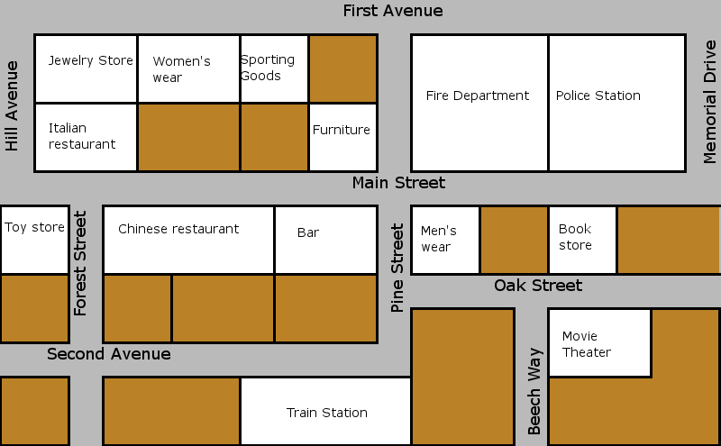
News
stand

Library
Clothing Store

Church
Parking lot

School
Park
Bank
Pharmacy

Hospital
Cal’s Cafe
Dry Cleaners
Super
market
Bus
stop
Gas
Station
Museum

● YOU ARE HERE
1)True or false
- The school is next to the pharmacy T F
- The bar is on the corner of Main St and Pine St. T F
- The police station is next to the Fire Department T F
- The toy store is across from the Chinese Restaurant T F
- The pharmacy is between the trains station and the hospital T F
- The hospital is across from the parking lot T F
- The neswsstand is between the library and the clothing store T F
- Cal’s Cafe is on the corner of Hill Ave. and Main St. T F
- The movie theater is next to the dry cleaners T F
- The gas station is across from Cal’s café.

2) Give directions

A: Excuse me. Where’s the supermarket?
You: The supermarket? Go _______ on ____________________ turn __________ on __________ it’s __________ from the museum.
A: Thank you!
You: ____________________.

A: Excuse me. Where’s the bank?
You: Go __________ on __________ turn __________ on __________ and turn __________ on __________ and again turn __________ on__________. The bank is __________ the Italian restaurant and the bus stop.

