THE BAD APPLE

One day, the bad apple arrives at the supermarket. She is sick from a trip to Greece. She is ugly, sick and scary. Her sickness is contagious and the fruits are getting ill. When the pears, strawberries and a watermelon are going rotten, the supermarket workers throw them into the bin. And it’s horrible; some of the fruits are scared.

After all this, the survivors hide in a freezer with the ice cream. They put a lock on the freezer and meanwhile they think of a plan.

At that time, the apple is alone and feels bad because the fruits don’t want to get close to her.

Otherwise, the fruits decide to look for medicine for the apple. They put on masks to protect themselves and they go to the medicine section. There, they find the right medicine and a syringe.

Then, the lemons, oranges and cherries distract the apple while the banana gives the apple a shot.
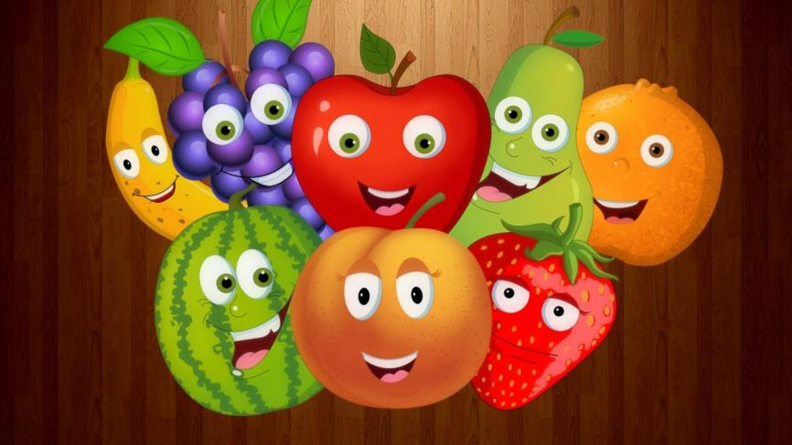

Immediately, the apple falls down and closes her eyes. The next morning she wakes up feeling great.

Finally, the supermarket workers bring new fruit and the fruits are very happy.

Magdalena Maroño Requejo

6º B

CEIP Cruceiro de Canido

