Hello again!!! A little review about places in a town. Do you dare to do it?
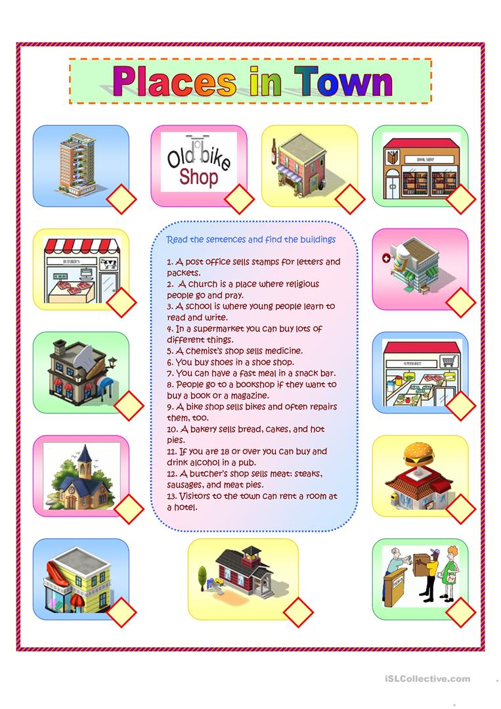
Read carefully and write the correct number in each square. Use a dictionary if you need it. You can copy the sentences on your notebook.

