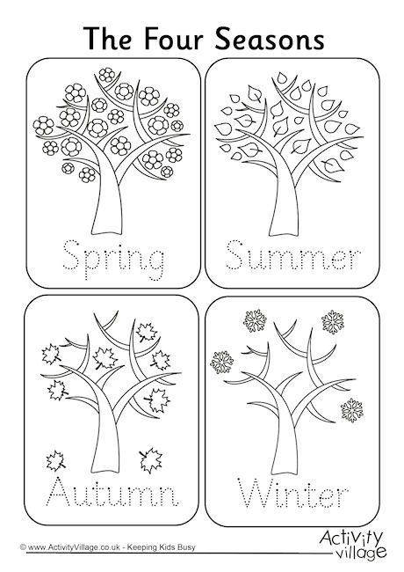
Last worksheet!!! Trace and color the trees.

See you on Monday!!! Lots of kissesssssss!!!!

